




UNIVERSITY OF GUELPH’S
MULTI-YEAR
ACCESSIBILITY PLAN
2025-2027


Table of Contents
Key Terms 2
Message from AVP-DHR 3
Land Acknowledgement 4
Mission 5
Goals 6
Progress Made During 2022-2024 7
Pillar 1: Attitudes, Behaviours, Perceptions and Assumptions 9
Pillar 2: Awareness and Training 10
Pillar 3: Assessment, Curriculum and Instruction 11
Pillar 4: Digital Learning and Technology 13
Pillar 5: Organizational Barriers 14
Pillar 6: Physical and Architectural Barriers 16
Pillar 7: Employment 19
Closing 21

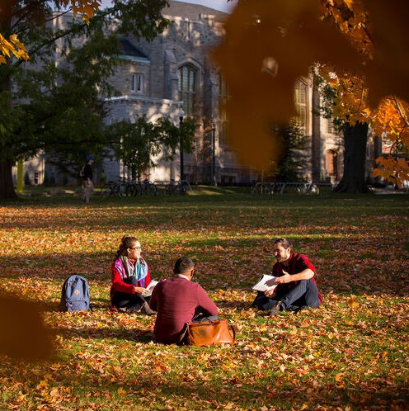
Key Terms
AODA - Accessibility for Ontarians with Disabilities Act
CCS - Computing and Communication Services
DHR - Office of Diversity and Human Rights
OHW - Office of Occupational Health and Wellness
OTL - Office of Teaching and Learning
PR - Physical Resources
PSE - Post Secondary Education Standards
SAS - Student Accessibility Services
SCS - School of Continuing Studies

2

Message

From the AVP,

Diversity & Human Rights

Making education inclusive and accessible is a key pillar of excellence at the University of Guelph. That’s because the University is an institution committed to providing accessible and inclusive learning and working environments where every member of our community can reach their full potential. We believe that creating a culture of belonging is directly related to our ability to achieve a high degree of institutional excellence and success.

Identifying and addressing barriers to full and equal participation at U of G will involve ongoing and evolving efforts, continuous assessment and strong action. According to Statistics Canada, 27 per cent of Canadians over the age of 15 experience a disability, a 4.7 per cent increase since 2017. As we build a strong foundation for a future U of G, our commitment to inclusion and accessibility and supporting our students, staff and faculty will be key components of our success.

This Accessibility Plan is designed to guide the University of Guelph’s ongoing efforts to enhance accessibility across campus, while providing a comprehensive framework for fostering an inclusive environment. It allows us to reflect upon our 2022-2024 goals and progress and make a strong plan for the future. Each section outlines key initiatives and strategies aimed at addressing various aspects of accessibility, from training and awareness to physical infrastructure improvements. It proposes new and innovative best practices and highlights many ley and groundbreaking initiatives.

The plan focuses on actions to not only comply with the Accessibility for Ontarians with Disabilities Act, but to fulfil our University’s commitment to building learning, working and living environments where every member of our community experiences an authentic sense of belonging.

The Multi-Year Accessibility Plan serves as a roadmap, outlining priorities and policies to foster equitable access to lifelong learning. Embedding accessibility best practices in our policies, practices and planning is a key component to U of G’s commitment to equity, diversity and inclusion on our campuses.


Over the next three years, we will work hard to fulfill our commitments, identify and address barriers to success, and continue to support the success of our students, faculty and staff.
Sincerely,
Indira Naidoo-Harris
Associate Vice-President, Diversity & Human Rights University of Guelph
3



Land Acknowledgement

The University of Guelph is situated on the unceded treaty lands and territory of the Mississaugas of the Credit and part of the Dish With One Spoon territory – An agreement between Haudenosaunee and Anishinaabeg and their allied nations to live peaceably on the lands throughout what is now known as the Great Lakes Region.


We express our gratitude to the many Indigenous peoples who have taken care of this land. As we continue to build an equitable, inclusive and accessible University, we acknowledge our shared responsibilities in understanding our relationship to the land and our place within its history.

4


Mission & Principles

Mission: To be a leader in inclusivity by building an accessible, equitable and inclusive University where everyone with a disability can actively participate in all facets of University life.

The goals for the 2025-2027 accessibility plan are derived from the priorities listed in the Accessibility for Ontarians with Disabilities Act (AODA) and the objectives of the proposed postsecondary education (PSE) standards committee. Our goals are informed by the following principles:

Accessibility efforts should be proactive, rather than reactive.

Disability is a critical aspect of diversity and intersectionality. There must be a recognition of intersectionality and the compounded impact of multiple identities.
Innovation should be celebrated and encouraged.


There is a shared responsibility for accessibility across all members of the university.

Emergency planning must be inclusive, ensuring accessibility for individuals with disabilities.


Accessible communication should be prioritized across all channels and networks, addressing the diverse needs of individuals with various disabilities.

Ongoing training on the AODA and its core domains should be a collective responsibility of all university members.
Note: The PSE standards committee is dedicated to enhancing the accessibility of publicly funded postsecondary institutions for persons with disabilities. Similar to the AODA, a key focus of these standards is addressing the needs of students with disabilities to ensure their full participation in campus activities. 5



Progress Made During 2022-2024

Progress Made During 2022-2024

During the 2022-2024 period, the University of Guelph made significant strides in advancing accessibility across campus, with key developments in policy, strategy, and inclusive practices.

A new resource was drafted by the Office of Diversity and Human Rights (DHR) that consolidates the integrated standards of accessibility, focusing on AODA’s Information and Communication Standards and outlining actionable process for education resource producers. Additionally, DHR developed an accessibility communication strategy, which was reviewed by the Accessibility Steering Committee and will be finalized in 2025. This strategy aims to enhance accessibility messaging and reach across the university community.

In 2016, the University conducted a campus-wise Exterior Accessibility Audit focusing on areas like parking lots, ramps and pathways. The Interior Accessibility Audit conducted from 2022 picked up where the exterior audit ended, by assessing entry doors and internal spaces for accessibility. The audit has covered 6.6 million square feet across 108 buildings on campus, spanning various building types and time periods. Further information about the implementation process is described in section “Pillar 6: Physical and Architectural Barriers”.

Accessible wayfinding signage has been installed throughout the Mackinnon complex for easier navigation to the elevators, washrooms and major wings of the buildings. This signage goes above and beyond the required Ontario building code compliance and helps students navigate this complex building. Our aim is to replicate this project elsewhere on campus where navigation is difficult.

DHR has also strengthened collaboration and accessibility efforts with key campus units such as the Office of Teach and Learning, McLaughlin Library, and Campus Ceremonies and Events to enhance supports and services for students, faculty and staff when it comes to accessibility.
6


Progress continued.
The University’s accessibility planning actively involves persons with disabilities and the Accessibility Steering Committee regularly integrates feedback from students, faculty, staff and advocacy groups with lived experience, to inform the development of future accessibility initiatives.

Key policy updates were made to enhance supports and services for persons living with disabilities at the University. These included revising protocols for support animals, updating accessibility contact information, clarifying communication procedures and developing alternative accessibility sensitive formats. In addition, the University focused on enhancing safety measures for employees with disabilities. A new initiative was created for better individualized emergency response plans in collaboration with Occupational Health and Wellness and Campus Safety.

The University also developed and updated training policies on accessibility for the university community. This included new trainings focused on emergency preparedness, library accessibility and making accessibility training mandatory for volunteers. In addition, signage and maintenance support were improved to make navigation for persons with disabilities on campus easier.

These are some of the efforts underway at the University. They reflect the significant strides the University of Guelph has made to foster an accessible, inclusive environment for all.

7


Pillar 1: Attitudes, Behaviours, Perceptions and Assumptions

Accessibility is Not Optional
The University of Guelph recognizes that accessibility is a foundational element of an equitable and inclusive academic environment. As such, accessibility must be integrated into every facet of campus life, from teaching and learning to the services and digital spaces we provide. Achieving this requires a systemic, proactive approach and will include the following efforts:
Computing and Communication Services (CCS) will publish a monthly community awareness newsletter with available training and education that includes digital accessibility best practices, sector news, and information sharing opportunities.
Student Accessibility Services (SAS) will implement a training module orientation on the shared responsibility of faculty, university administration, SAS, Library Accessibility Services (LAS), and the student regarding student accommodations.
The Office of Teaching and Learning (OTL) will incorporate guidance on accessible and equitable learning environments, teaching practices and course design in its programming and resources for faculty and instructors.
The School of Continuing Studies (SCS) will continue to design and develop online courses that follow best practices in accessibility, incorporating the Universal Design for Learning (UDL) framework, W3C Web Accessibility Initiative (WAI) guidelines, and AODA standards.
OTL will review and revise criterion for the evaluation of teaching and learning awards and grants it manages in relation to considering accessible and inclusive pedagogy.
DHR will review and update the Accessible Service Provision Module and Making Education Accessible modules.
OTL will incorporate criteria in its teaching and learning grants requiring applicants to describe how they will make their projects and work accessible and emphasize inclusion when hiring students as partners.


Accessibility Champions
To centralize expertise and foster a culture of inclusion, DHR and the Accessibility Steering Committee will establish a core team of Accessibility Champions. These champions will undergo professional accessibility training, enabling them to act as key resources and trainers for their respective areas. Drawn from diverse units across the University, this team will ensure accessibility efforts are coordinated and will promote collaboration and reduce siloed practices.
Accessibility will be explicitly included in job descriptions and postings, particularly for roles in marketing, IT, and other critical areas.
Accessible teaching practices and requirements will be emphasized and supported through targeted
resources and accountability mechanisms. 8

Pillar 2: Awareness and Training

The University of Guelph is committed to fostering a culture of accessibility through targeted training and awareness programs. These initiatives aim to ensure that all faculty, staff, and students are equipped with the knowledge and tools they need to create an inclusive environment while minimizing training redundancies.

Accessibility Training for New Faculty and Instructors
Accessibility awareness will become a core component of faculty and instructor onboarding, with new hires encouraged to participate in updated training modules, including New Days and Principles of Belonging.
Training modules will be updated and tailored to meet the specific needs of different departments. Where appropriate, training content will be made publicly accessible via the Digital Learning
Commons (DLC).

Employee Accessibility Training Program
To ensure accessibility knowledge is integrated across all staff roles:
Current trainings will be scheduled and incorporated into employee onboarding processes.
Workshops on digital accessibility conducted by CCS will become a part of staff orientation. These sessions, piloted in Fall 2024, will be refined based on feedback and fully scheduled for 2025.
New leader awareness training lead by Human Resources Organizational Development will include an Occupational Health and Wellness (OHW) module that will focus on the accommodation process, including legal duties and institutional protocols.

Training for Student Employees
Accessibility training will extend to student staff, including part-time employees, co-op students, research assistants (RAs), and teaching assistants (TAs).
Digital accessibility training will be offered three times a year to student staff in relevant roles by CCS (e.g., media/communications and IT). These sessions will be integrated into the HR training portal and advertised through Experience Guelph.
Employers of student staff will be responsible for ensuring their participation in training sessions, which will be offered throughout the year for flexibility.

9


10
Pillar 2
continued

Web Accessibility Awareness
The Digital Accessibility Resource Committee (DARC) will conduct audits of university websites to identify common compliance issues. Findings will be shared with key teams, including Communications and Marketing (C&M) and Web Services, to promote broader awareness and remediation efforts.

Institutional Training Standards on Neuro-inclusion
Neuro-inclusion will be embedded in institutionally sanctioned programming.
DHR and the SCS will provide neuro-inclusion and universal design training for faculty, staff, and students. These trainings will focus on creating an inclusive environment for neurodivergent individuals, ensuring that all learning spaces, activities, and resources are accessible, promoting equal participation and fostering a culture of respect and support.
OTL and the SCS will provide expertise and guidance in developing institutional training as it relates to Universal Design for Learning and neuro-inclusive principles in teaching and learning.

Campus-Wide Training Coordination
To reduce redundancy and training fatigue, all accessibility training initiatives provided by various stakeholders will be reviewed and harmonized by DHR. A comprehensive suite of offerings will be developed, ensuring all community members receive consistent, high-quality accessibility training.

By aligning training efforts and embedding accessibility awareness across all levels, the University of Guelph will cultivate a truly inclusive community.




Pillar 3: Assessment, Curriculum and Instruction

The University of Guelph is committed to embedding accessibility into all aspects of teaching, learning and assessment. By equipping faculty with actionable resources and fostering inclusive teaching practices, the University aims to create equitable academic experiences for all students.

Clarifying Faculty Responsibilities for Accommodations
Faculty play a critical role in implementing Student Accessibility Services (SAS) accommodations. To ensure they are fully aware of their responsibilities, SAS will:
Update accommodation descriptions to clearly outline action steps for faculty.
Provide faculty with accessible, user-friendly guides to support the implementation of accommodations effectively and efficiently.

Accessible Teaching Toolkit
An Accessible Teaching Toolkit will be developed to assist library employees in creating inclusive learning environments. This resource will include:
Accessible Teaching Framework: A structured approach to guide faculty in incorporating accessibility into their curriculum, pedagogy, and assessment.
Engagement Tools and Strategies: Practical methods for fostering accessible and meaningful library interactions with students.
Accessible Email Templates: Pre-designed templates to streamline library communication and ensure inclusivity in outreach and workshop registration.

Establishing Accessibility Guidance in Teaching and Learning
OTL and the SCS will collaborate with university administration and service units to establish robust accessibility guidance. This guidance will:
Be informed by leading research and frameworks such as the Universal Design for Learning (UDL) Guidelines v3.0 and Ontario Universities’ Accessible Campus Guidelines for Educators.
Aligning efforts with relevant recommendations, such as Recommendation 14, which supports diverse perspectives on inclusion.

11

Pillar 3
continued

Inclusive Planning for Workshops, Conferences and Events
To ensure accessibility in all event planning, workshops and conference delivery, we will formalize inclusive practices in our Accessibility Framework. Current and future efforts include:
Polling registrants to identify and accommodate accessibility needs.
Utilizing tools such as closed captioning whenever possible, in online workshops to enhance inclusivity.
Applying additional accessibility resources to ensure both content and event formats are accessible for all participants.
By embedding accessibility into assessments, curriculum, and instructional practices, the University of Guelph reaffirms its dedication to inclusive education and equitable opportunities for all learners.


12


Pillar 4: Digital Learning and Technology

In an increasingly digital world, the University of Guelph is committed to ensuring that its digital content and technology are accessible to all members of the community. This includes not only the content itself but also the processes by which accessibility is evaluated, addressed and maintained.

Monitoring and Remediation of Inaccessible Web Content and Documents
CCS will establish a structured process to monitor digital content, focusing on website accessibility and document compliance. This process will include:
Regular audits of digital content to identify accessibility barriers, ensuring compliance with university standards.
A robust tracking system to monitor the remediation of identified accessibility issues, ensuring timely updates and improvements.

Accessible PDFs
All PDF documents produced by the University will be required to meet accessibility standards. While PDFs are often convenient, they can pose significant barriers for users with disabilities if not properly formatted. As part of the University’s efforts to improve accessibility:
All PDFs must be made fully accessible, following industry best practices.
CCS together with accessibility partners will strongly encourage the use of more accessible formats, such as HTML or Word documents, to reduce reliance on PDFs whenever possible.

Through these efforts, the University of Guelph will ensure that digital learning environments and content are accessible for all students, faculty, and staff, fostering an inclusive and equitable academic community.

13

Pillar 5: Organizational Barriers
14

The University of Guelph recognizes the need to address organizational barriers that impede access and inclusion for individuals with disabilities. Overcoming these barriers requires continuous collaboration, clear policies and targeted strategies to ensure that all students, staff and faculty have equal access to opportunities and services.

Service Animal Policies and Procedures
OHW will work closely with various units across campus to refine and enhance its Service Animal Policies and Procedures. This will include:
Ensuring consistency in the implementation of service animal accommodations across departments.
Clarifying roles and responsibilities to support the inclusion of service animals on campus while respecting the rights and safety of all community members.

Plain Language Communication
To improve the clarity and accessibility of communications across campus, DHR will provide training opportunities in and bring awareness to plain language communication. These initiatives will be inspired by the Plain Language Standards as outlined by Standards Canada. This initiative will focus on:
Simplifying communication, especially for critical documents and public-facing materials, to ensure they are easily understood by all members of the University community.
Training staff on the principles of plain language and the importance of accessible communication.

Improving Communication with People with Disabilities
The library will enhance its efforts to communicate effectively with individuals with disabilities by implementing several key initiatives:
Surveying individuals with disabilities to better understand their perceptions of library accessibility policies and communications.
Using feedback from the survey to review and revise policies, to improve website communications, and improve Library programming and services for students with disabilities.

Through these strategies, the University of Guelph will address organizational barriers, creating a more inclusive environment where individuals with disabilities can fully participate and thrive.

Pillar 6: Physical and Architectural Barriers

Accessibility in the built environment is essential for the University of Guelph to meet the standards of the AODA. By ensuring spaces are inclusive and barrier-free, the University fosters an equitable environment where everyone - students, faculty, staff and visitors - can fully participate in campus life.

Modernizing Design and Construction Standards

The University’s Physical Resources Design and Construction Standards (referred to as “the Standards”) guide the planning, design and construction of all campus facilities. These Standards incorporate current building codes, industry best practices and the University’s preferred design approach to support the internal design team and external consultants to ensure that our built environment is inclusive and accessible to everyone. The Standards also establish the University’s minimum expectations for renovations and new construction, ensuring consistency, quality, ease of maintenance and operational efficiency.
PR will modernize the Standards to assist during the planning, design and construction of all University facilities.
PR will develop new accessibility-focused content for the Standards, which will reflect the Our Time
Strategic Plan for a more accessible and inclusive built environment.
PR will recommend, wherever feasible and appropriate, going above AODA (Design of Public Spaces Standards) and Ontario Building Code minimum (OBC Section 3.8) to use best practice guidelines such as Facility Accessible Design Standards (FADS) and CSA-B651 Accessible Design for the Built Environment. These guidelines cover specialized spaces, such as labs or kitchens, that neither the AODA or OBC give direction on.

Interior Accessibility Audit
The Interior Accessibility Audit completed in 2024, details the findings of the visual inspections and provides an itemized checklist of items that can make the University’s built environment more accessible and meet compliance requirements. This checklist includes details about cost estimates, priority rankings, and risk levels.
Based on the comprehensive audit and checklist:
Physical Resources (PR) will compile and implement projects to enhance accessibility of identified built environment areas.
An Open House will be held to share findings with the campus community.

It is important to note that accessibility standards are ever evolving and existing conditions are “grandfathered”. However, the University is committed to providing an inclusive built environment and will correct high priority deficiencies through the advancement of projects in this and future Capital Plans.

15

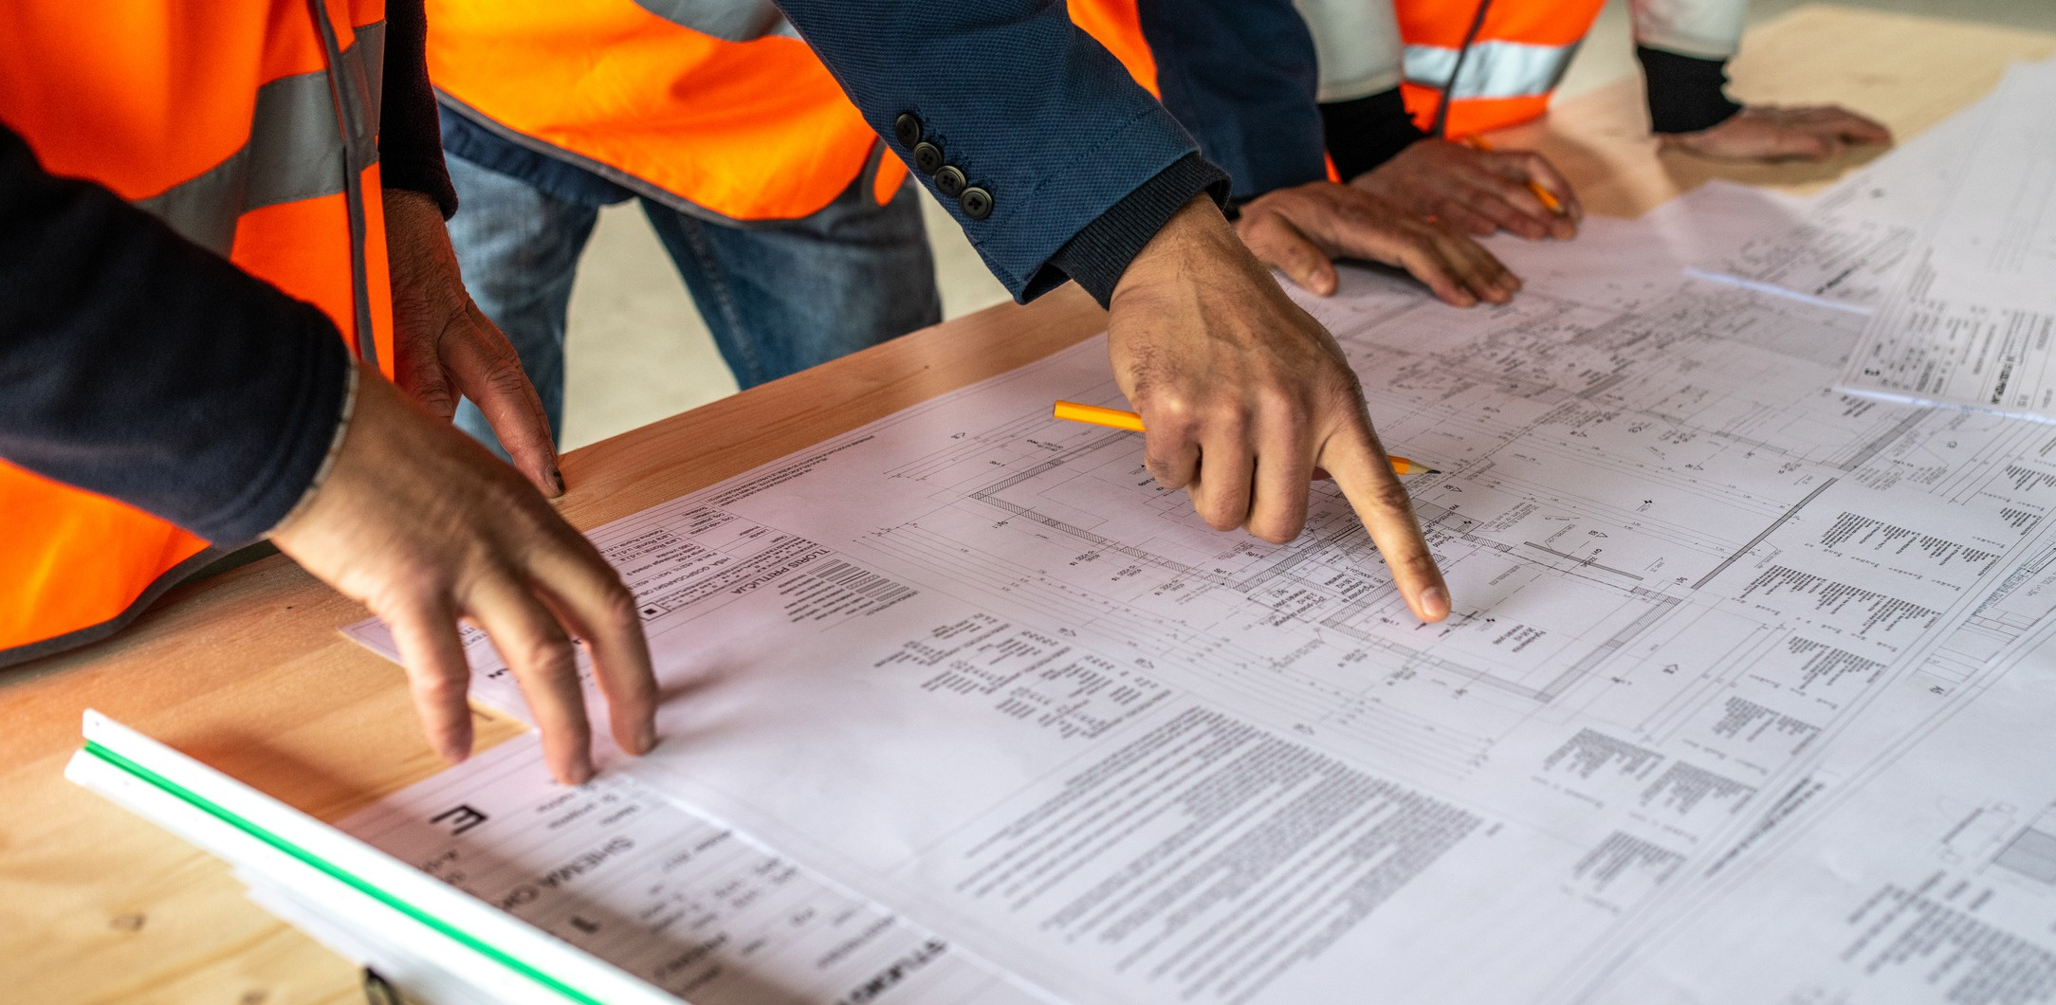
16
Pillar 6
continued

Exterior Stair Replacement Program and Automatic Door Operators (ADO’s)
The goal of the Exterior Stair Replacement is to repair the University’s aged infrastructure while adding accessibility features such as detectable warning surfaces, colour contrasting nosing, continuous handrails and appropriately scaled risers and treads.
PR will also continue to work on the Exterior Stair Replacement program.
PR will continue and expand the ongoing efforts to install Automatic Door Operators (ADO’s) on campus including, front entry doors and to communal washrooms (021 Zavitz, 031 Alexander Hall, 022 Raithby House, 024 Massey Hall and 068 McKinnon Building).

AODA Compliance in the Procurement of Consulting and Construction Services
PR is also implementing AODA compliance in the procurement of Consulting and Construction services. These efforts include:
Request for Proposals (RFP) overseen by PR will require a successful proponent and their sub- consultants who will be working with the public (students, faculty, staff, visitors or other third parties), or on behalf of the University to agree to comply with the accessibility standards established under the AODA and the University’s accessibility policies.
Provide training on the requirements of the accessibility standards to those employees working with the public (students, staff, faculty, visitors or other third parties) at, or on behalf of, the University and who participate in developing the proponent’s policies, practices or procedures.
Keep record of completed training.
Provide training records when required by the University.

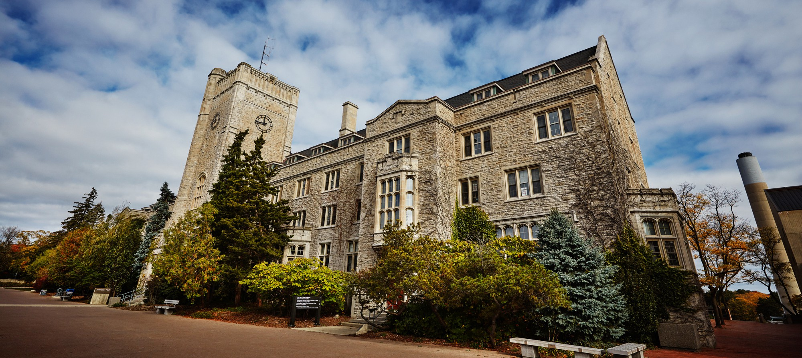
17
Pillar 6
continued

Maintenance and Impact to Accessible Spaces
Through the PR Work Order Desk, staff, faculty and Student Accessibility Services (SAS) on behalf of students, are able to submit complaints and improvement suggestions regarding accessibility issues in the built environment on campus. The issues are assigned to the appropriate parties for action such as the PR lock-shop (for a broken door), grounds (to clear exterior pathways) or the Associate Director of Campus Planning & Asset Management for more complex issues. The larger issues that require coordination, planning and funding are review for feasibility and implementation efficiencies with other projects, or bundling for potential cost saving.

The Work Order Desk also issues Notices of Work (NOW) and Shut Down Notices (SDN) when there are service disruptions or closures across campus in both interior and exterior spaces. These notices include anticipated timeframes, contact information and description of the work. All parties on our distribution list receive notices via e-mail in advance of planned and unplanned disruptions. For issues affecting vertical circulation such as Elevators, we have a curated Elevator Service Disruption Notice that includes Student Wellness, Computing & Communication Service (CCS) and SAS, who distribute the information to students across campus who will be affected. Temporary signage is hung in the area of work by the maintenance staff. For longer term shutdowns on planned construction projects, signage to re-route folks to another barrier free path of travel is erected on a project-by-project bases. It will generally also indicate the timeframe of the closure and contact information of the Project Manager in charge.
PR will modify the NOW or SDN protocol to include better consistency and reach in communication for accessibility-related service disruptions.
Winegard Walk Renewal (from 071 McLaughlin Library to 016 Day Hall) - PR is demolishing an existing service ramp which has received numerous accessibility complaints. It will be replaced with accessible pathway and feature landscaping that will revitalize this very busy central campus promenade.
011 Johnston Hall - New Barrier Free Entrance (on South side) with lift access to the first and basement floors. This includes access to the Guelph Campus Co-op Bookstore for students, which has received numerous accessibility complaints as it is currently only accessible via stairs.


Pillar 7: Employment

The University of Guelph recognizes the importance of inclusivity in the workplace and is committed to continuously improving policies and practices to support employees with disabilities. This commitment is crucial as the University works to ensure that all aspects of employment— from hiring to accommodations and emergency response— are accessible and equitable for individuals with disabilities. The following key initiatives and reviews are focused on improving accessibility and inclusion within the university’s employment practices.

Review and Update of Accommodation Partnership Agreements
The University will conduct a review of the four existing Accommodation Partnership Agreements, including:
General Agreement
UGFA (University of Guelph Faculty Association) UGFA Unit 1
CUPE 3913
These agreements outline the rights and responsibilities of the University and its unionized employees with respect to workplace accommodations. The review process will focus on ensuring that all accommodations are effectively integrated into the workplace, that the needs of employees are met in a timely manner, and that the language and provisions of the agreements remain relevant and legally compliant.

Review of Individualized Emergency Response Plans
The Individualized Emergency Response Plans (IERP) will be thoroughly reviewed and updated to reflect current best practices in emergency preparedness. These plans are designed to ensure that employees with disabilities are provided with the necessary support during emergencies, taking into account specific needs and circumstances. The review will examine how the plans are communicated to employees, the adequacy of the accommodations outlined, and the process for regularly updating the plans. Additionally, DHR will explore ways to ensure that all employees with disabilities are informed about the availability of IERPs and are encouraged to create a plan that meets their individual needs.

18



Closing
The University of Guelph is committed to creating a fully accessible and inclusive environment for all. This Accessibility Plan represents both our ongoing efforts and our vision for a more equitable campus, where every member of our community has access to the resources and opportunities they need to thrive.

We recognize that achieving true accessibility is a continuous process that requires collaboration across all levels of the University. This plan outlines clear goals and actions, but its success depends on the collective efforts of faculty, staff, students, and community partners. Together, we can ensure that accessibility becomes embedded in everything we do—from teaching and learning to physical spaces and digital environments.

We encourage all members of our University community to engage actively with this plan, whether through participating in training, providing feedback, or championing accessibility within their own areas.

We are excited to continue this journey of progress and transformation, and we thank you for your commitment to making the University of Guelph a more accessible place for all.

19

